**EXCERCISE 1**

**Ban đầu :**

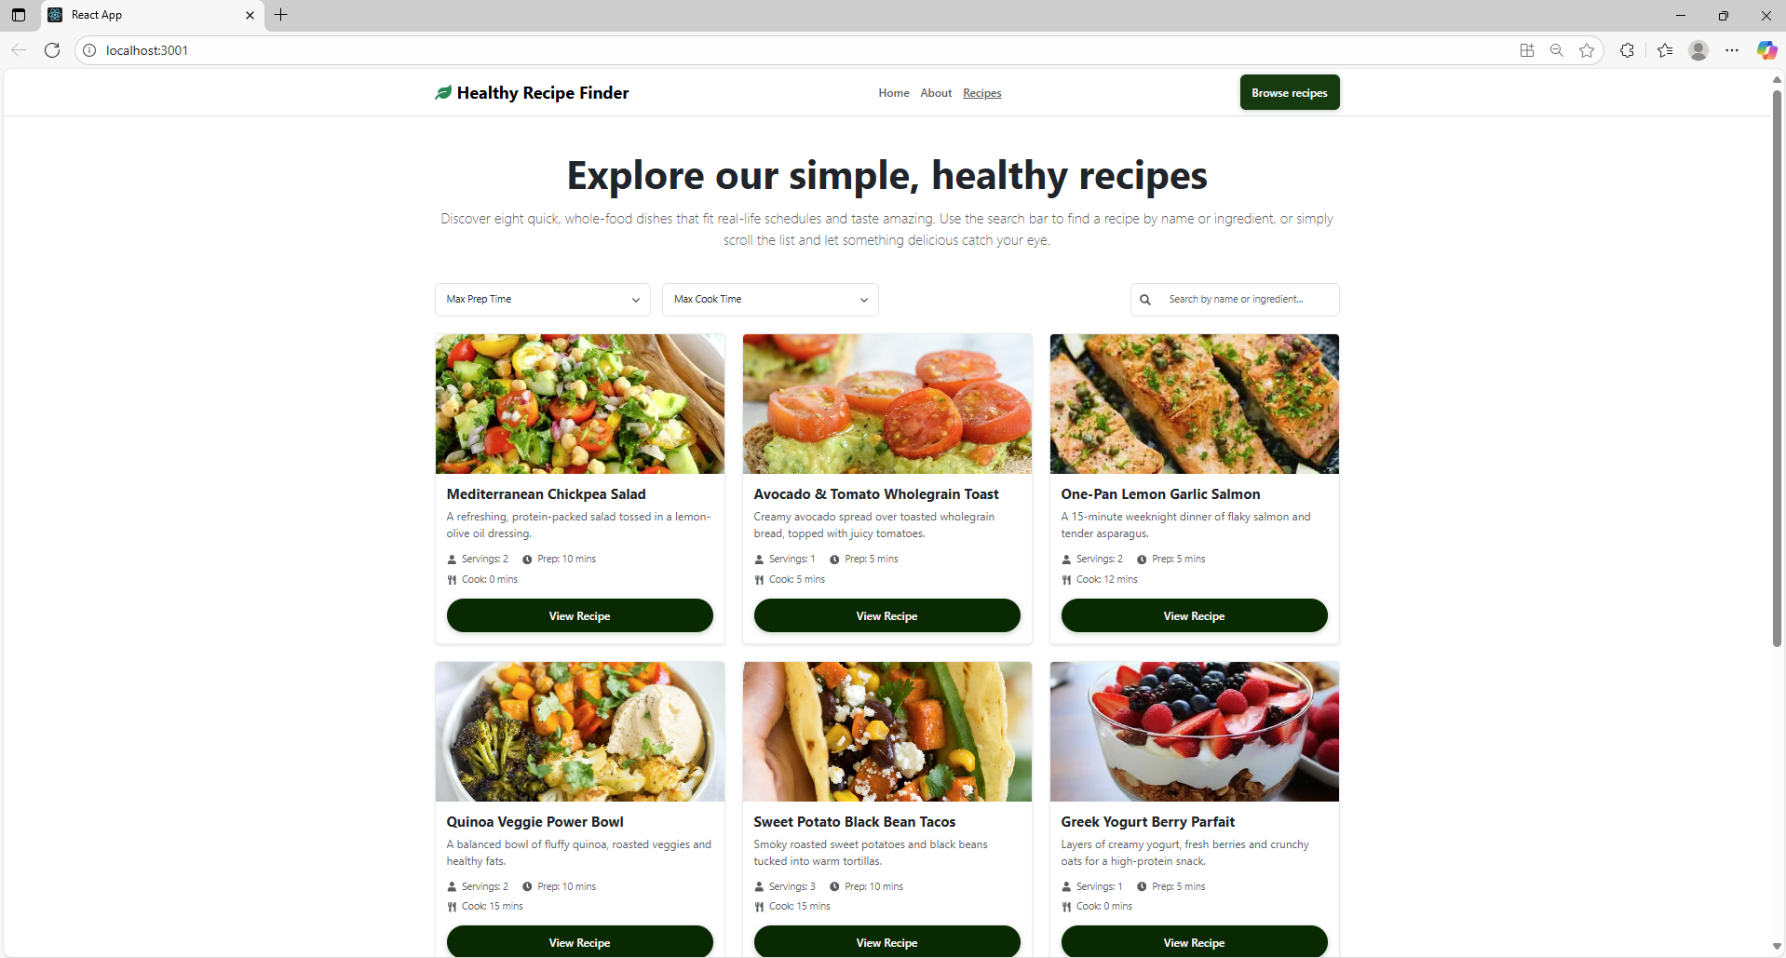

-Sau khi filter Max Prep Time:

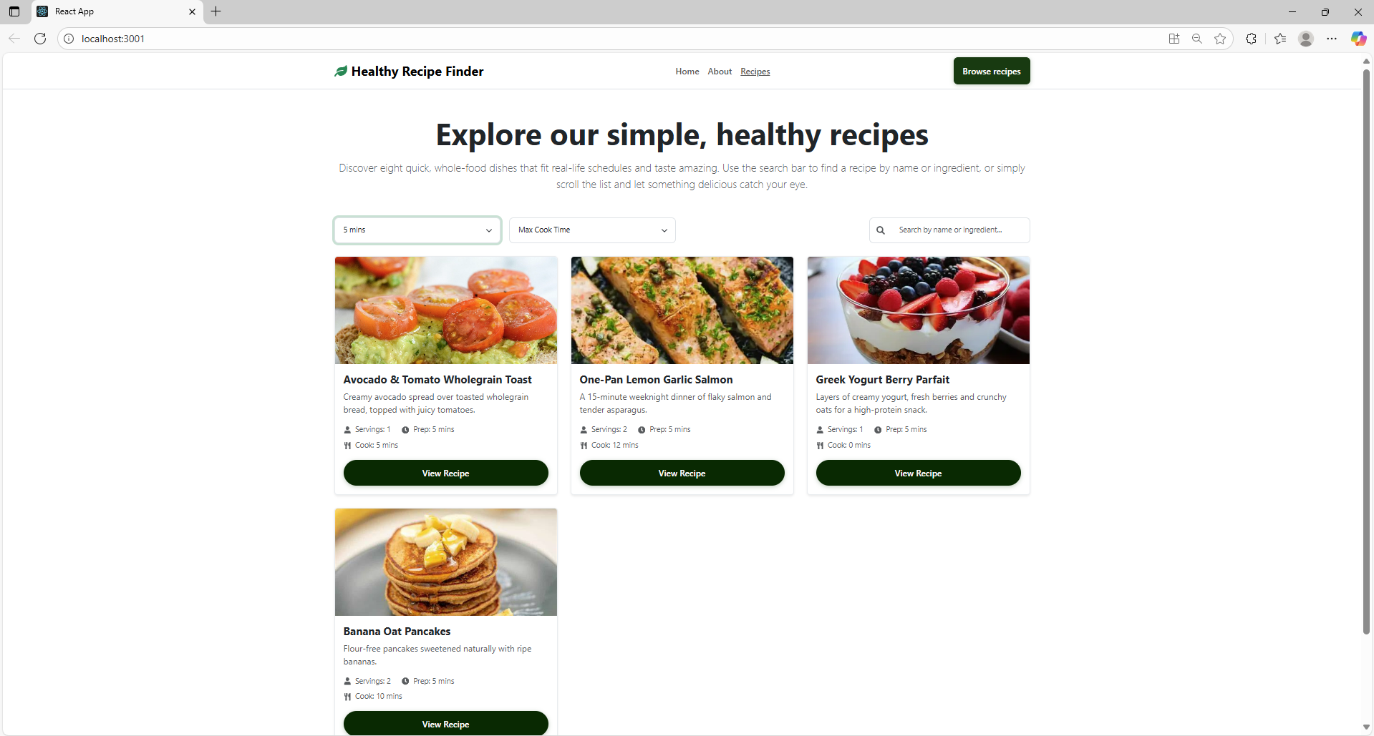

-Sau khi filter bằng Max Cook Time:

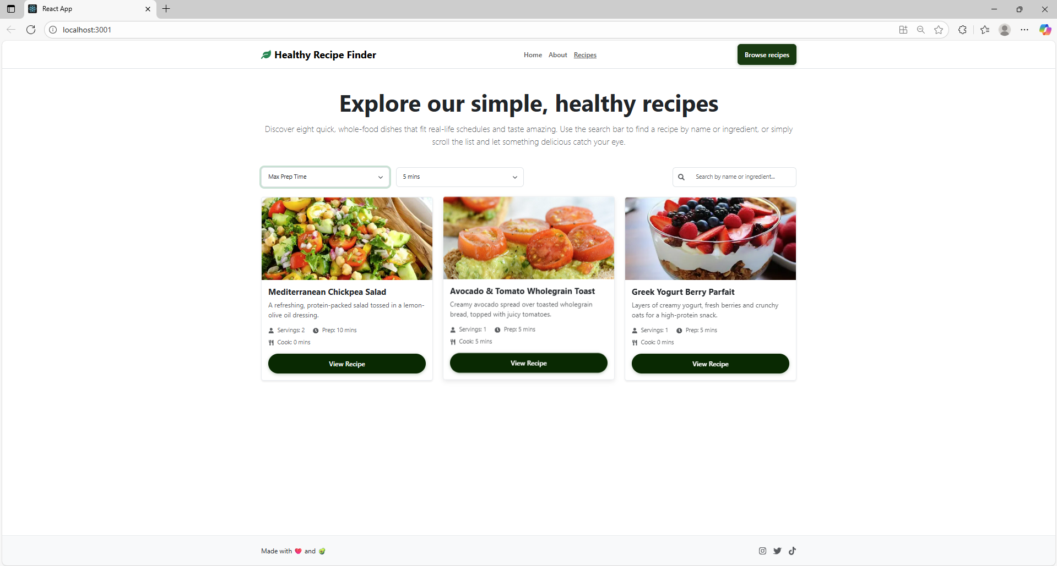

-Sau khi search name:

